DBMS LAB 1

GAURAV MAHAJAN

PES1UG20CS150

ASSUMPTIONS:

TRAIN HAS N=5 COMPARTMENTS.

SEAT AVAILABILITY IS BOTH COMPARTMENT WISE AND ALSO TRAIN WISE WHEN THE USER CHECKS THE AVAILABILITY.

COST IS CALCULATED USING THE FARE TABLE ON A FARE PER KM CHARGE THUS ALLOWING USERS TO BOARD AND ALIGHT THE TRAIN ON THE STATION AS PER THEIR CONVENIENCE.

TASK A

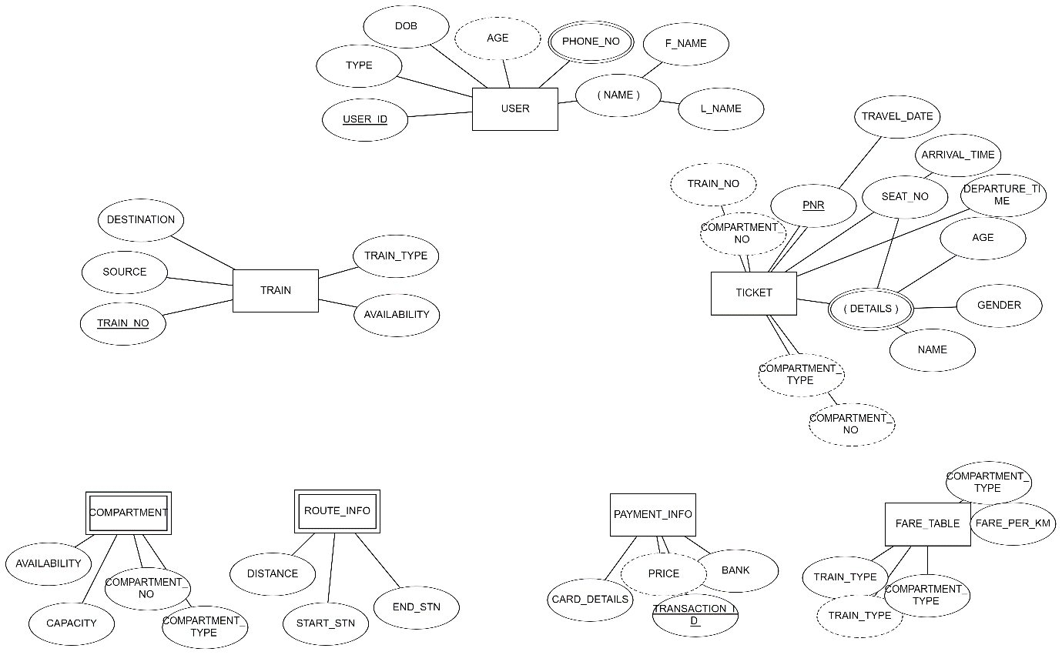

TASK B

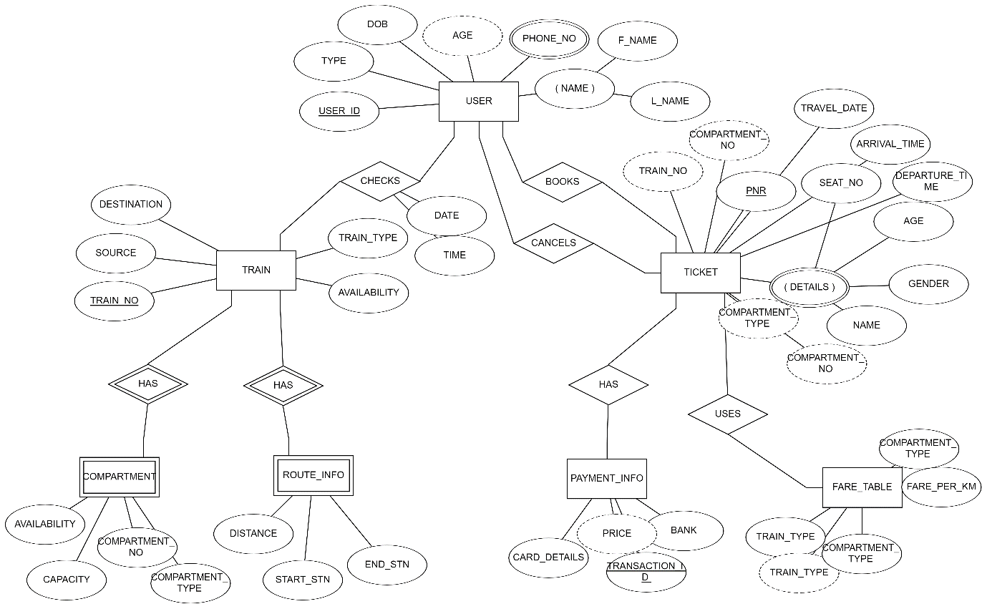

TASK C

